**Combustion System**

**Combustion System (Normal)**

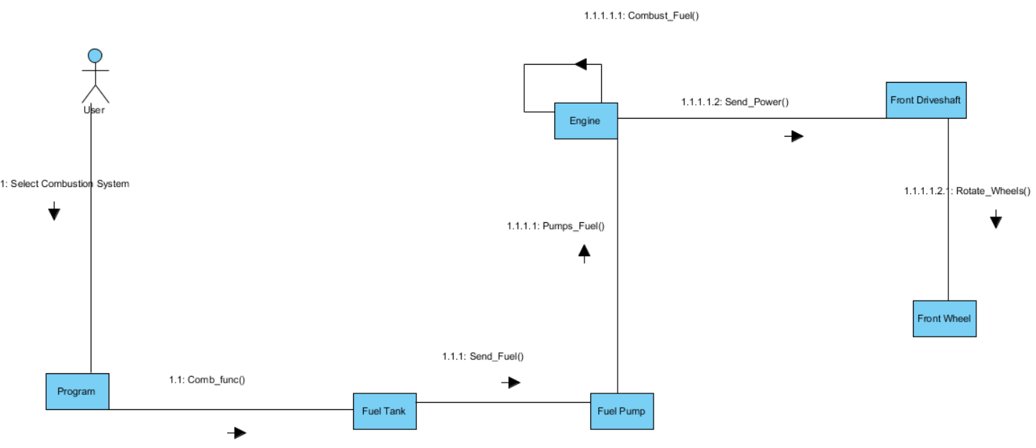

**Combustion System (Inclined)**

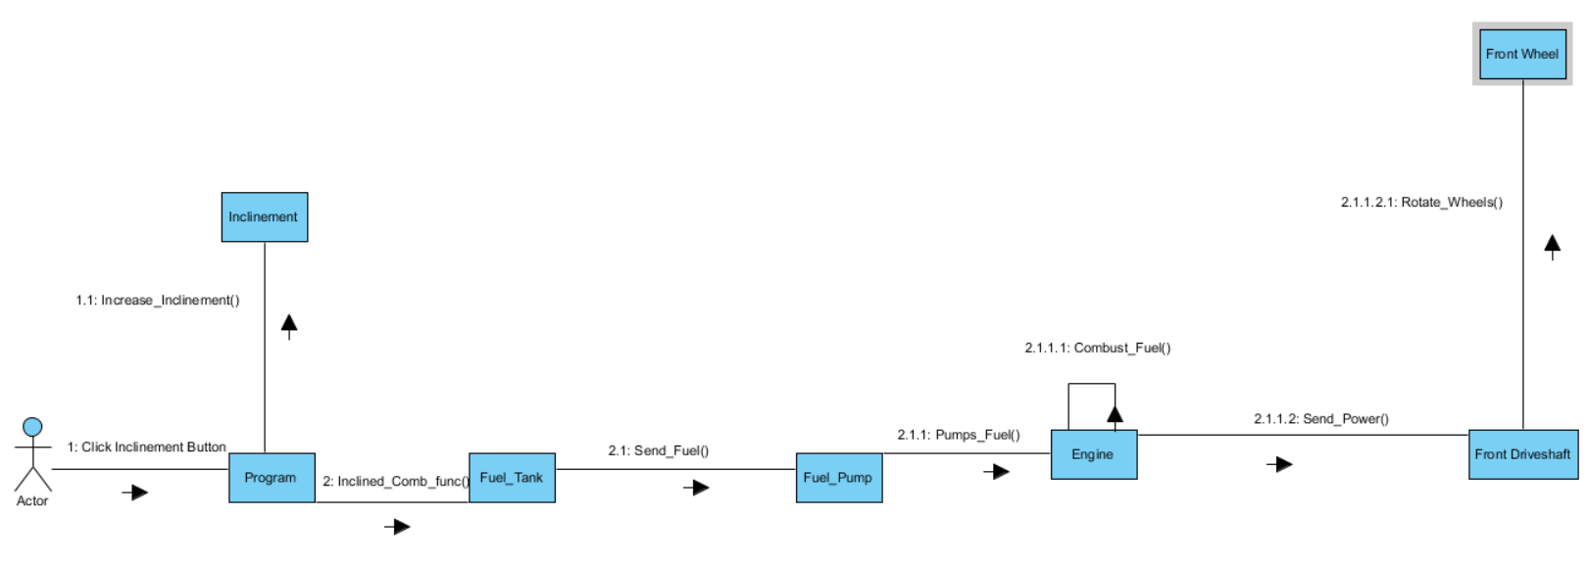

**Combustion System (Low Fuel)**

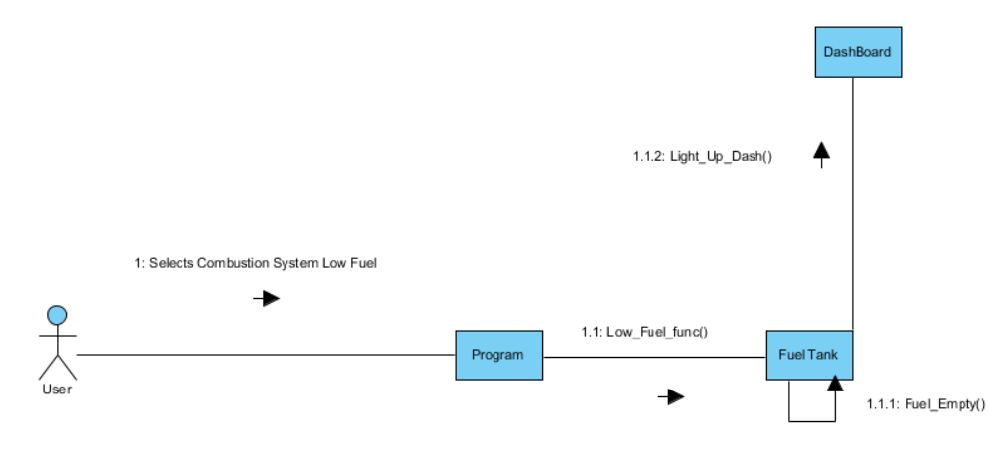

**Combustion System (Incorrect Fuel)**

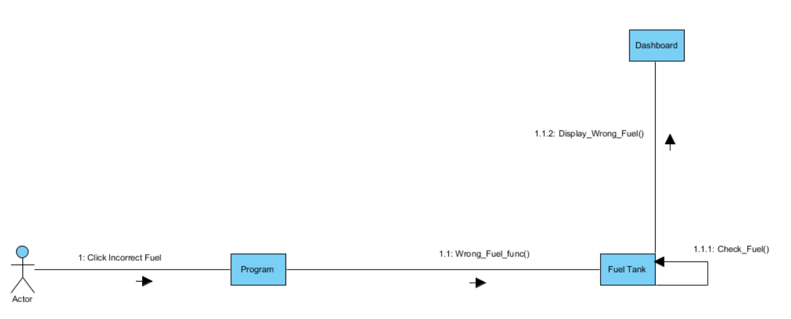

**Drive Wheel System**

**Front Wheel Drive System**

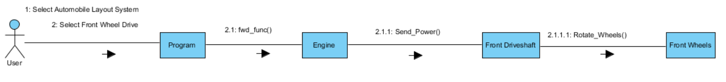

**Rear Wheel Drive System**

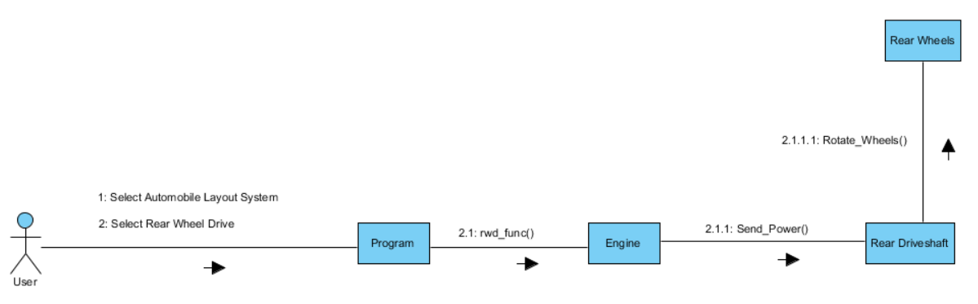

**Four Wheel Drive**

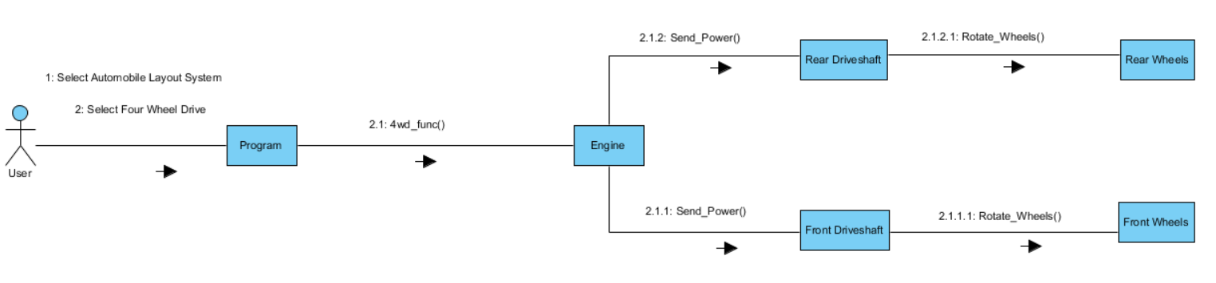

**Cooling System**

**Cooling System (Normal Temp)**

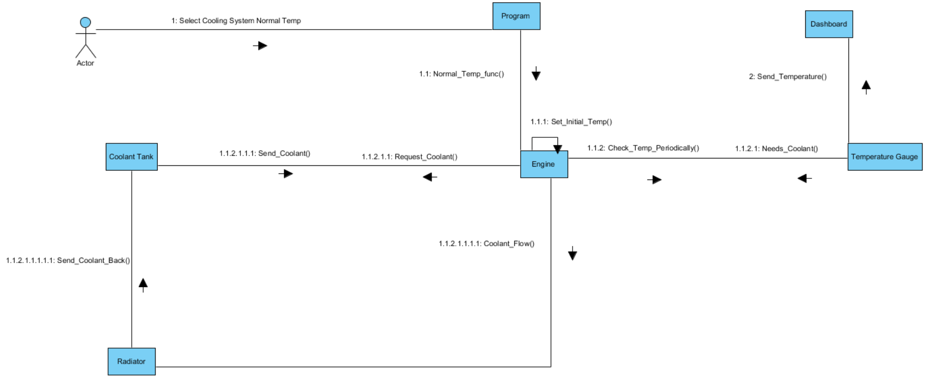

**Cooling System (High Temp)**

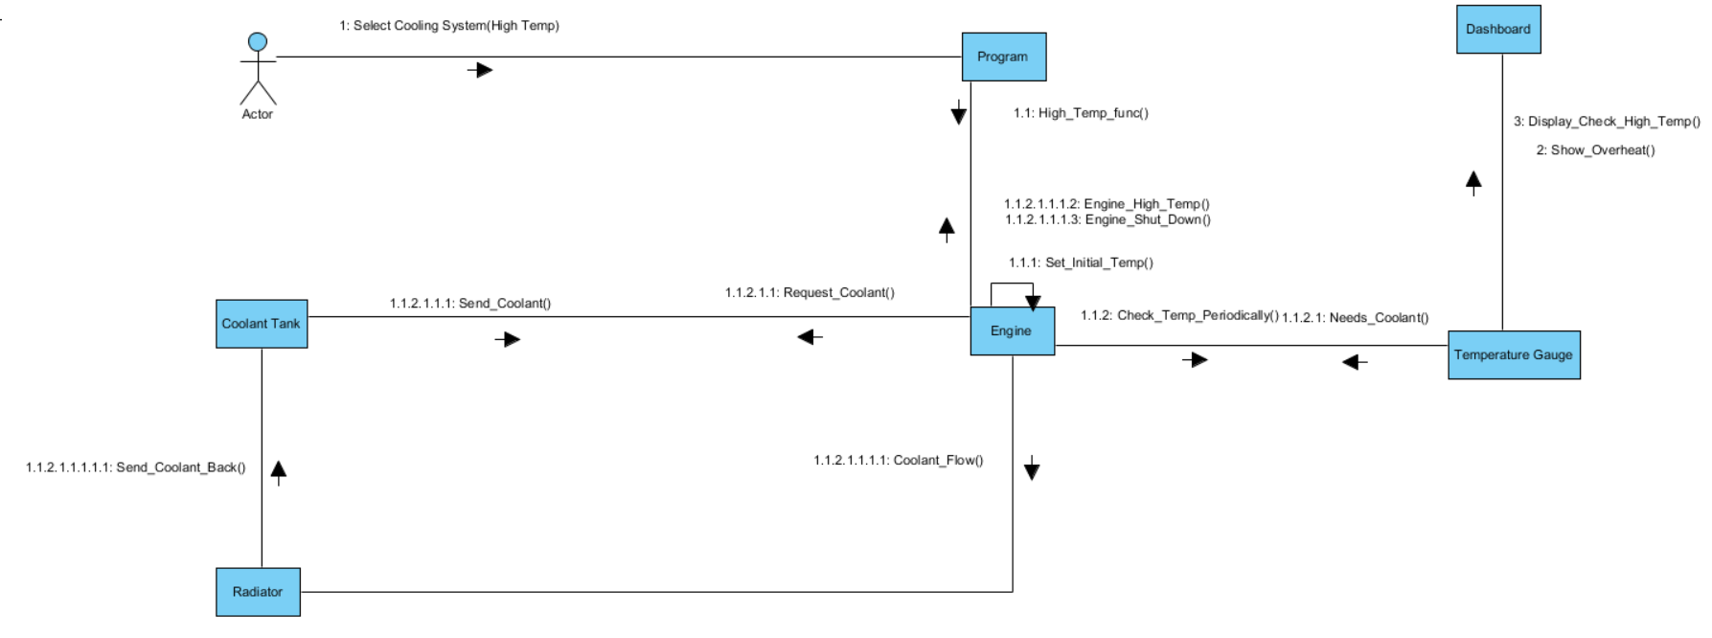

**Electrical System**

**Electrical System (Audio System)**

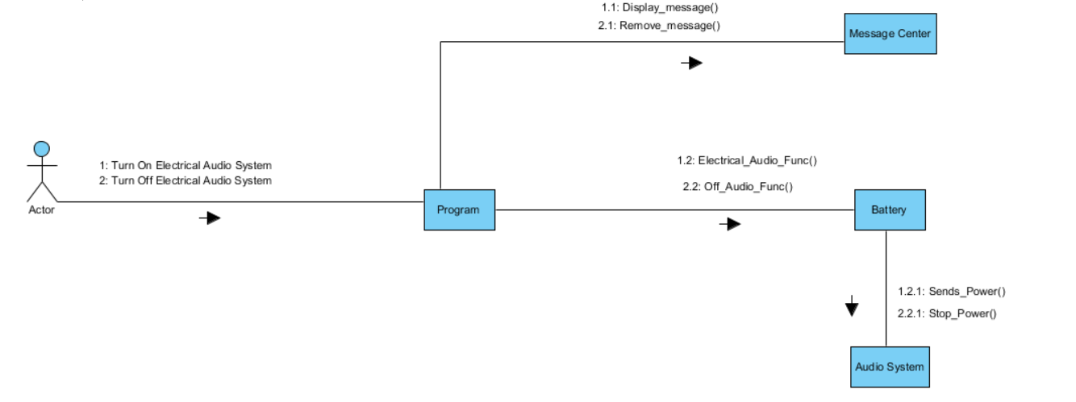

**Electrical System (Cruise Control)**

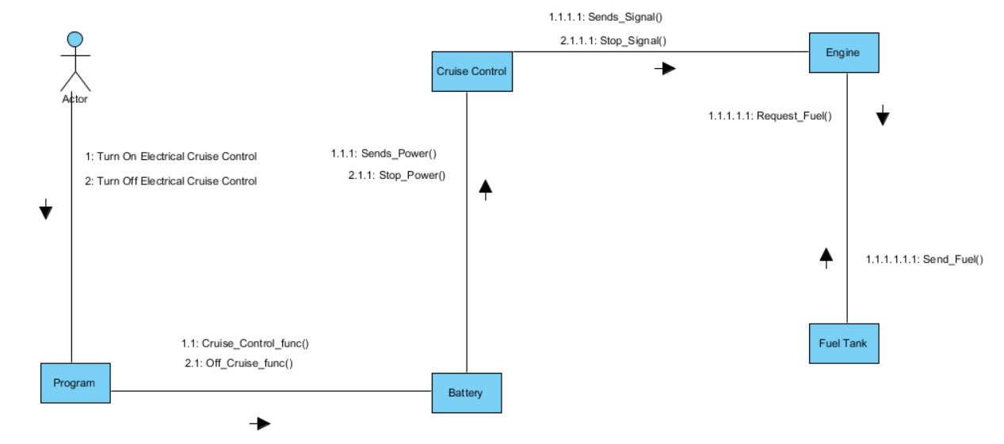

**Electrical System (Headlights)**

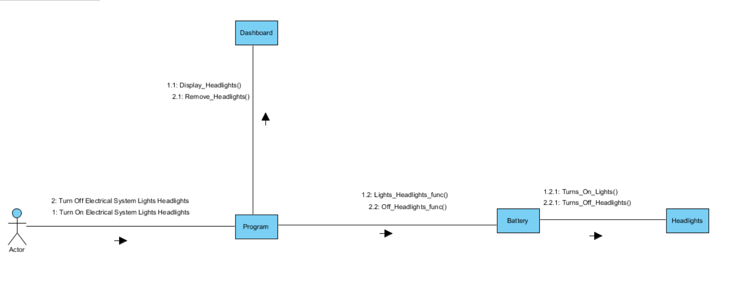

**Electrical System (High beams)**

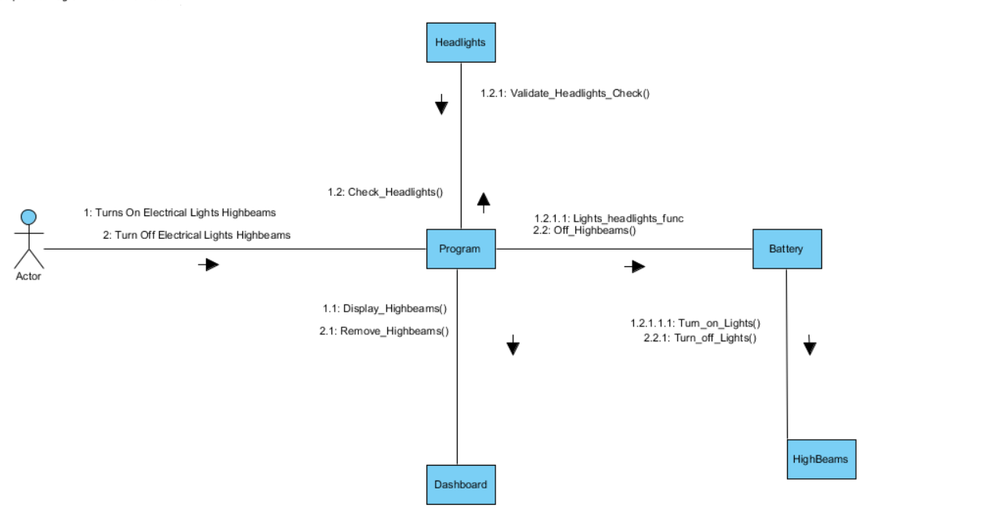

**Electrical System (Lights Hazard)**

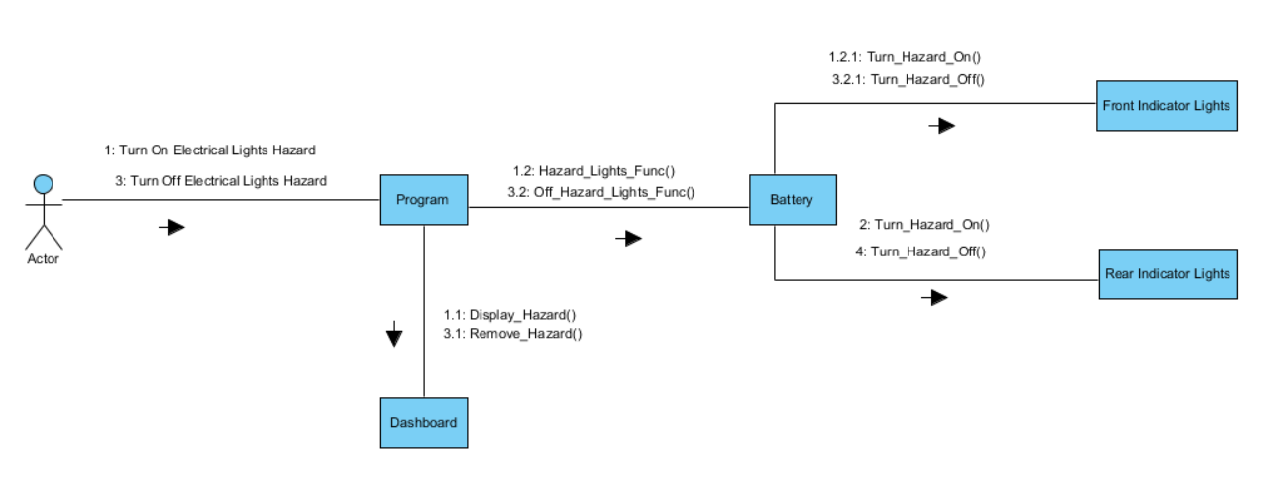

**Electrical System (Rear Fog Lights)**

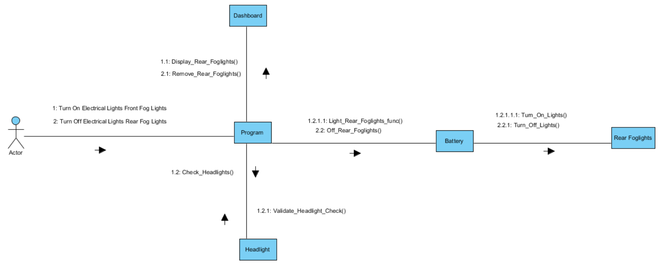

**Electrical System (Turn on Front Fog)**

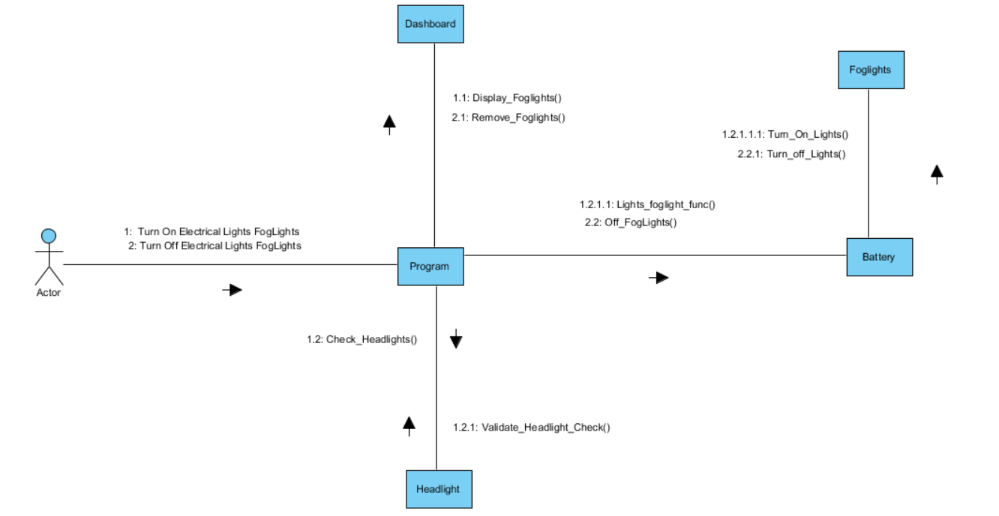

**Electrical System (Window Defrost)**

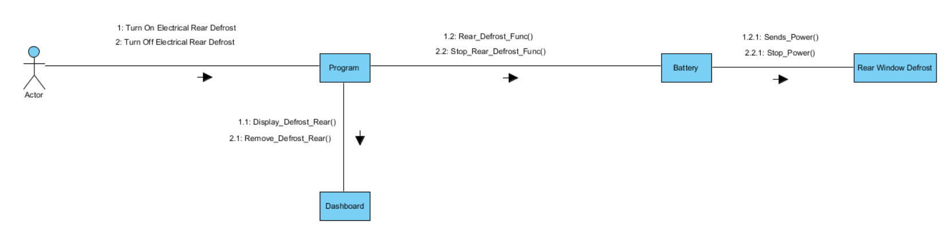

**Electrical System (Wiper)**

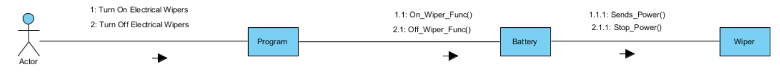

**Steering System**

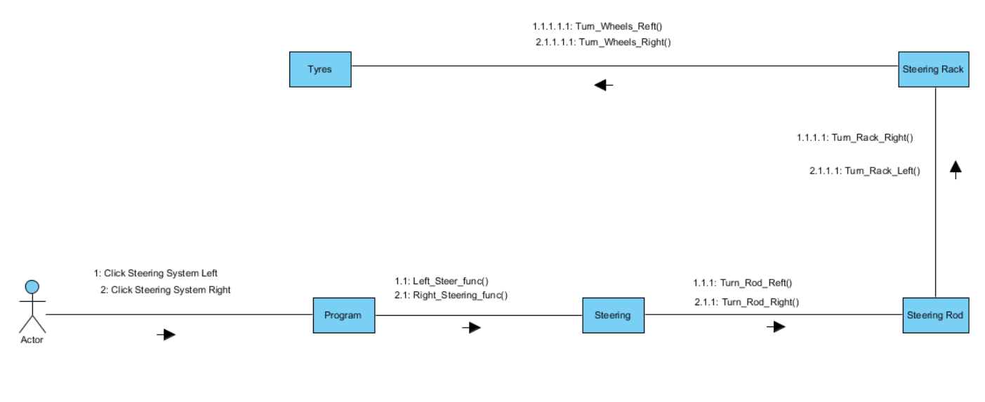

**Braking System**

**Braking System (Foot Brake)**

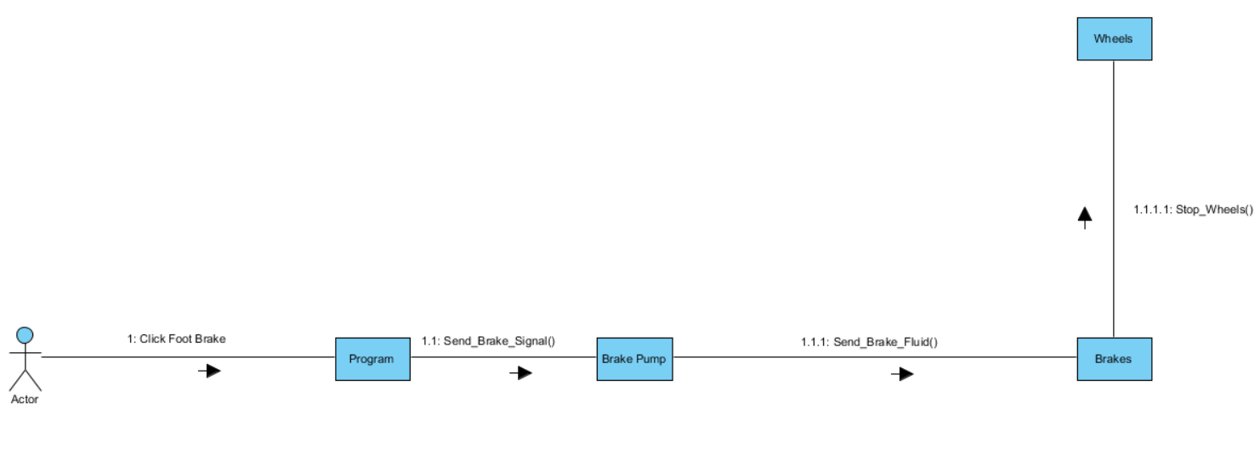

**Braking System (Hand Brake)**

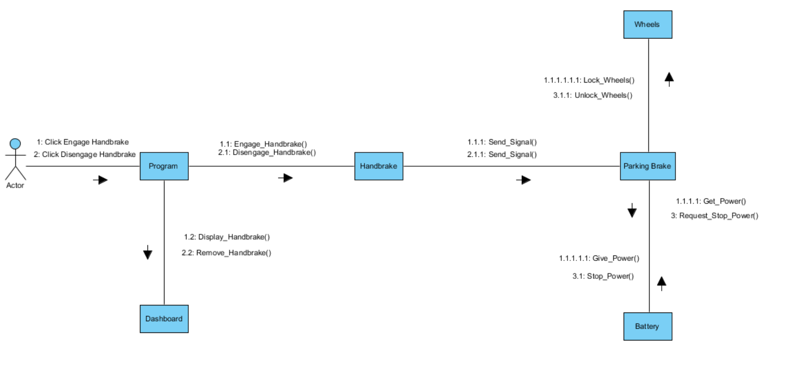

**Attachment System**

**Attachment System (Add Attachment)**

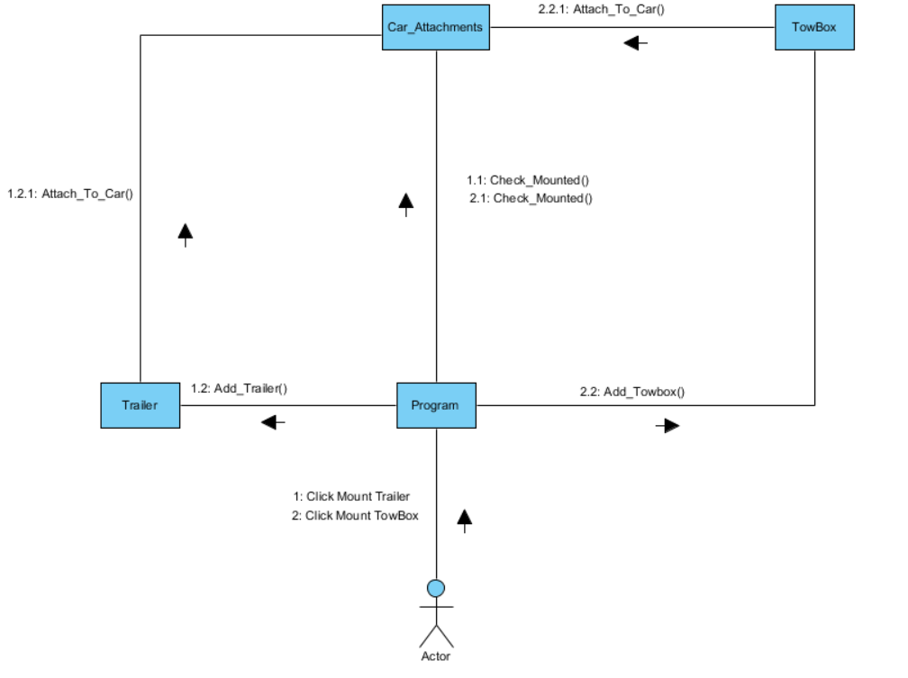

**Attachment System (Remove Attachment)**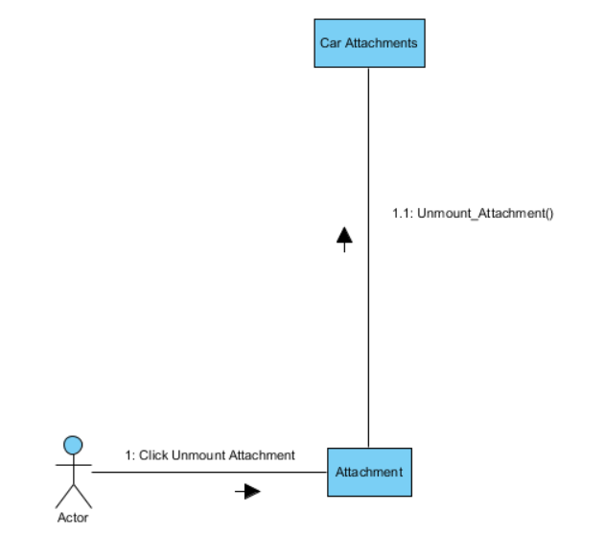

**Alternative Fuel System**

**Alternative Fuel System (Electric)**

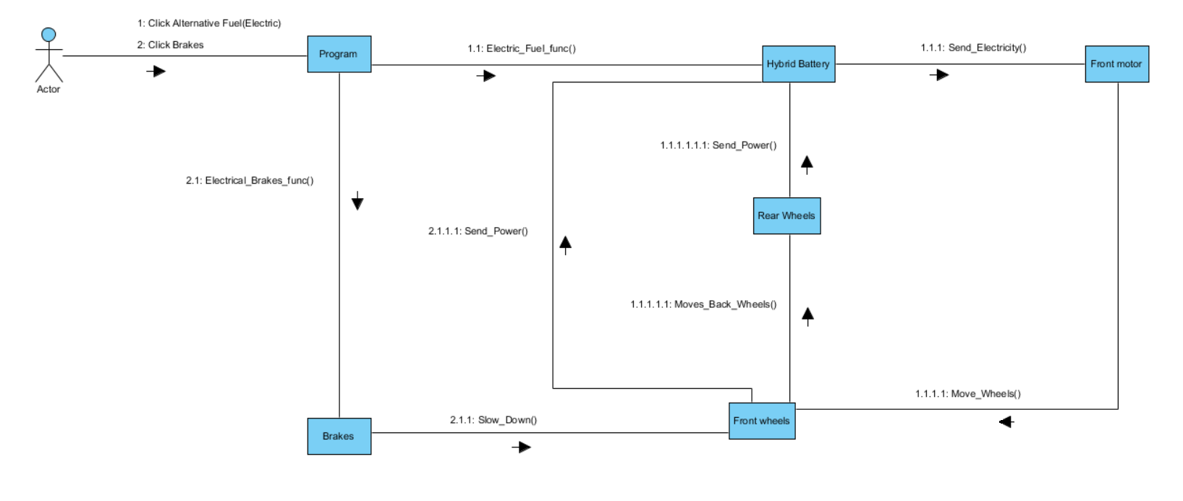

**Alternative Fuel System (Hydrogen)**

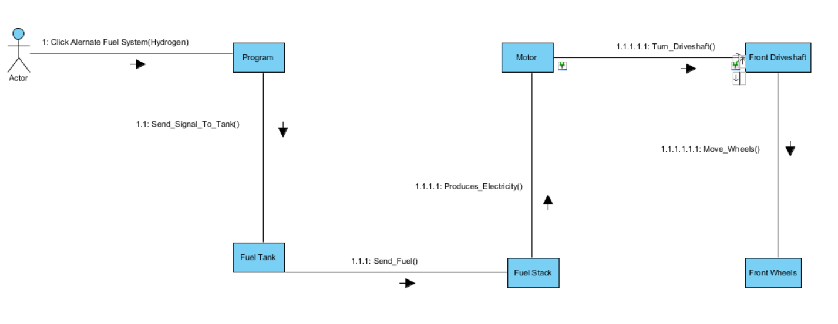

**Alternative Fuel System (Hybrid)**

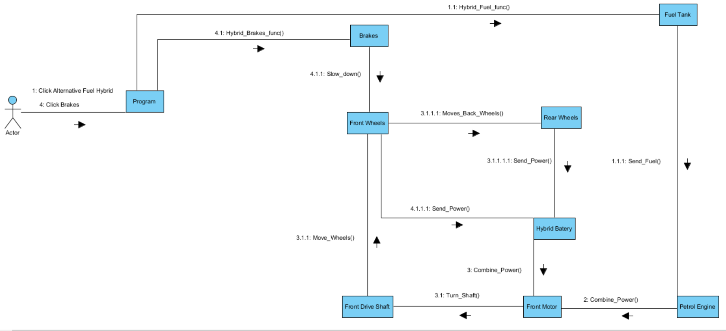

**High Altitude Driving System**

